All tubes are pre-labeled by the manufacturer | 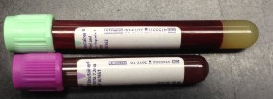 | Label contains tube expiry date.

CORRECT PATIENT’S LABEL PLACEMENT
- Place patient’s collection label (no larger than 2” X 1”) directly over manufacturer’s label to ensure that the specimen is visible.
- Align label lengthwise directly under the stopper, with patient’s name reading left to right.
 | 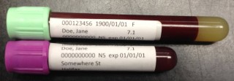 | Label must be stuck on smoothly

INCORRECT PATIENT’S LABEL PLACEMENT
 | 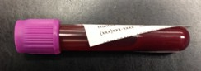 | Not straight/upside down
 | 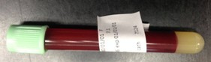 | Wrapped around
 | 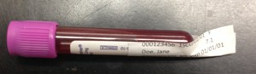 | Extending beyond tube
 | 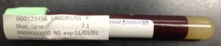 | Over cap

